Model A5
I.
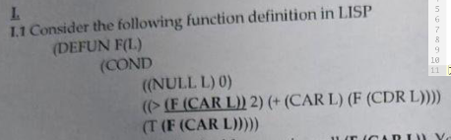
(DEFUN F (L)
(COND
((NULL L) 0)
(T ((lambda (v)
(cond
((> v 2) (+ (car L) (F (cdr L))) )
(t v)
)
)
(F (car l) )
)
)
)
)
// sau pune tot cond in lambda
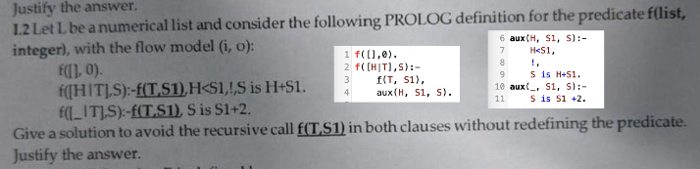
f([], 0).

f([H|T], S) :-
f(T, S1),
f_aux(H,S1,S).
f_aux(H,S1,S):-
H<S1,!,
S is H+S1.
f_aux(_,S1,S):-
S is S1+2.
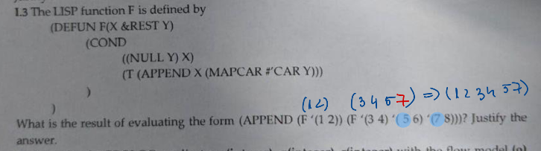
(F ‘(1 2)) -> we only have X => (1 2)
(F ‘(3 4) ‘(5 6) ‘(7 8))
->MAPCAR #’CAR ( (5 6) (7 8) ) => (5 7). Y = ( (5 6) (7 8) ), so we apply car on each element of Y => 5, 7. Pentru ca avem %rest Y, toate argumentele dupa cel pentru X sunt puse intr-o lista => Y va fi o lista cu 2 liste
-> APPEND X (MAPCAR #’CAR Y) => (3 4 5 7)
=> (1 2 3 4 5 7)
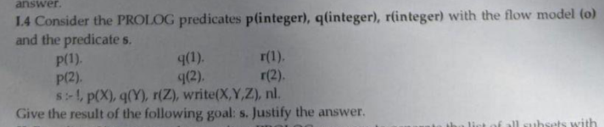
111
True
112
True
121
True
122
True
211
True
212
True
221
True
222
True
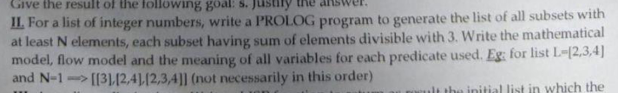
sum([],0).
sum([H|T],S):-
sum(T, S1),
S is S1+H.
subset([],[]).
subset([H|T], [H|Sub]):-
subset(T,Sub).
subset([_|T],Sub):-
subset(T,Sub).

valid(L,N):-
length(L,Len),
Len>=N,
sum(L,Sum),
0 is Sum mod 3.

sublists(L,N,Rez):-
subset(L,Rez),
valid(Rez,N).

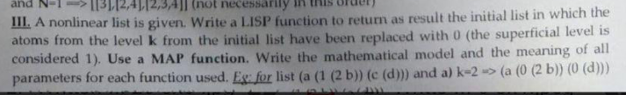
(defun replaceK (L k lvl)
(cond
((and (atom l) (= k lvl)) 0)
((atom l) l)
(t (mapcar #'(lambda (x) (replaceK x k (+ 1 lvl))) l))
)
)
(print (replaceK '(a (1 (2 b)) (c (d))) 2 0))

Model A1
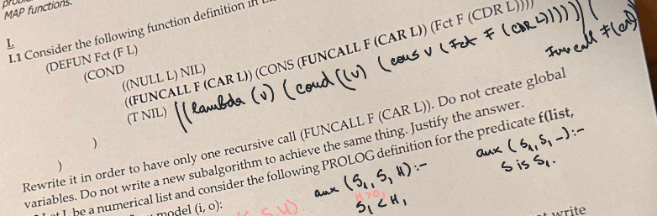
(DEFUN Fct (F L)
((lambda (v)
(cond
((null l) nil)
((v) (cons v (Fct F (cdr L))))
)
)
(Funcall F(car L))
)
)
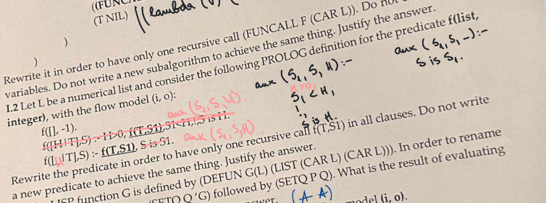
f([],-1).
f([H|T],S):-
f(T,S1),
aux(H,S1,S).
aux(H,S1,S):-
H>0,
S1<H,!,
S is H.
aux(_,S1,S):-
S is S1.
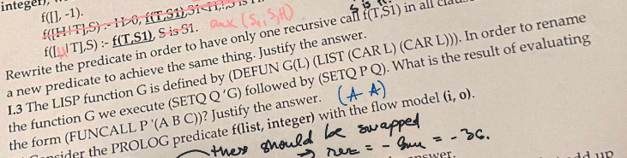
P e evaluat ca si Q, care e evaluat ca G => G (1 2 3) => (A A)
Doesn’t work with apply
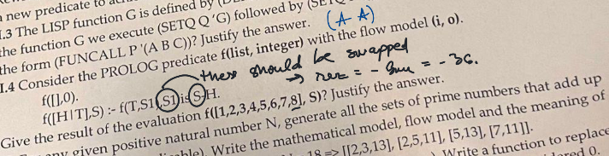
? Arguments are not sufficiently instantiated, pentru ca S e output parameter dar noi il folosim la scadere.
Daca era S is S1-H atunci aveam: 0-8-7-6-5-4-3-2-1=-36
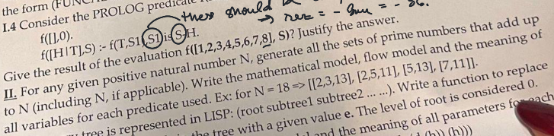
candidate(N,N).
candidate(N,I):-
N>1,
N1 is N-1,
candidate(N1,I).

generate(N,Rez):-
candidate(N,I),
prime(I),
generate_aux(N, [I], I, Rez).

generate_aux(N, Col, N, Col).
generate_aux(N, [H|Col], CurrSum, Rez):-
candidate(N,I),
I<N,
I<H,
prime(I),
Sum is CurrSum+I,
Sum=<N,
generate_aux(N, [I,H|Col], Sum, Rez).

prime(2).
prime(N):-
N>2,
\+ has_divisor(N,2).
has_divisor(N,D):-
D*D=<N,
N mod D =:=0,!.
has_divisor(N,D):-
D*D=<N,
N mod D \= 0,
D1 is D+1,
has_divisor(N, D1).
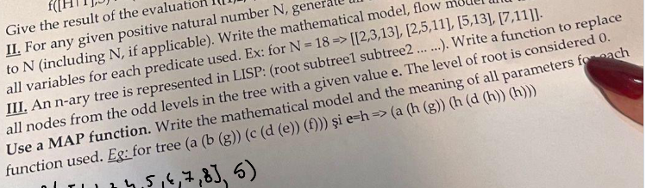
(defun replaceK (L e lvl)
(cond
((and (atom l) (= 1 (mod lvl 2))) e)
((atom l) l)
(t (mapcar #'(lambda (x) (replaceK x e (+ 1 lvl))) l))
)
)

(print (replaceK '(a (b (g)) (c (d (e)) (f))) 'h -1))
Incepem cu -1 pentru ca atunci cand intram prima data in functie, mergem direct la cazul 3 care o sa faca (+ 1 level) => root o sa fie la nivelul 0

Model ?
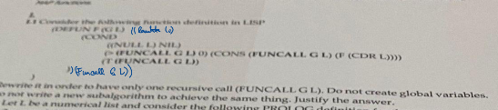
(DEFUN F(G L)
((LAMBDA (x)
(COND
((NULL L) NIL)
((> x 0) (CONS v (F (cdr l))))
(t v)
))
(FUNCALL G L))
)
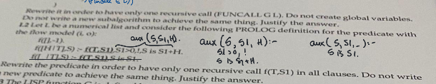
f([], -1).
f([H|T], S) :-
f(T, S1),
aux(S,S1,H).
aux(S,S1,H):-
S1>0, !,
S is S1 +H.
aux(S,S1,_):-
S is S1.
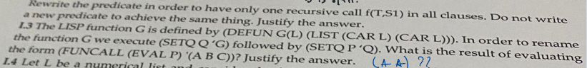
(A A)
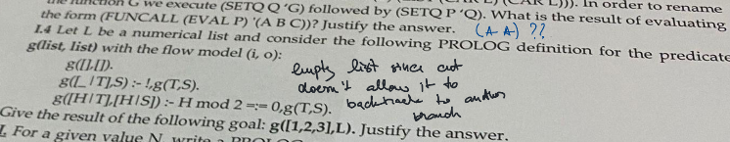
g([1,2,3],L).
- Always goes into the second clause because of ! which does not allow it to backtrace and go to the other clause. In the end goes into the first clause and returns the empty list.
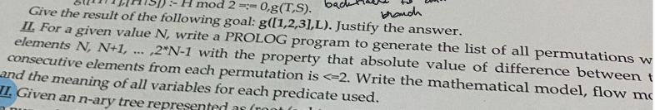
candidate(N,N,Max):-
N<2*Max.
candidate(N,I,Max):-
N<2*Max,
N1 is N+1,
candidate(N1,I,Max).

generate_candidate(N,E):-
candidate(N,E,N).

valid_diff(A,B):-
abs(A-B)=<2.

perm(N,Rez):-
generate_candidate(N,E),
perm_aux(N,[E],1,Rez).

perm_aux(N,Col,N,Col).
perm_aux(N,[H|Col],Lg,Rez):-
Lg<N,
generate_candidate(N,E),
\+ member(E,[H|Col]),
valid_diff(E,H),
Lg1 is Lg +1,
perm_aux(N,[E,H|Col],Lg1,Rez).

% V2
range(Max,Max,[Max]):-!.
range(A,B,[A|Col]):-
A<B,
A1 is A + 1,
range(A1,B,Col).

insert(E,L,[E|L]).
insert(E,[H|T],[H|Rez]):-
insert(E,T,Rez).

perm([],[]):-!.
perm([H|T],P):-
perm(T,P1),
insert(H,P1,P).

check([H1,H2]):-
abs(H1-H2)=<2.
check([H1,H2|T]):-
abs(H1-H2)=<2,
check([H2|T]).

sol(A,B,P):-
range(A,B,L),
perm(L,P),
check(P).
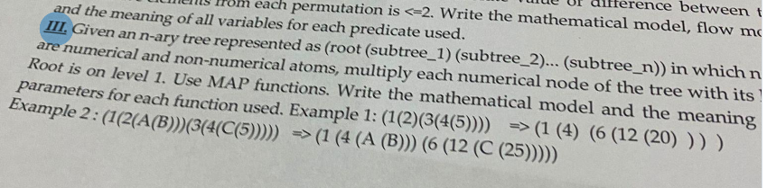
(defun mult(l lvl)
(cond
((numberp l) (* l lvl))
((atom l) l)
(t (mapcar #'(lambda (x) (mult x (+ 1 lvl))) l))
)
)
(defun mainMult(l)
(mult l 0)
)
(print (mainMult '(1 (2) (3(4(5))))))
(print (mainMult '(1 (2 (a (b))) (3 (4 (c (5)))))))

Model A6
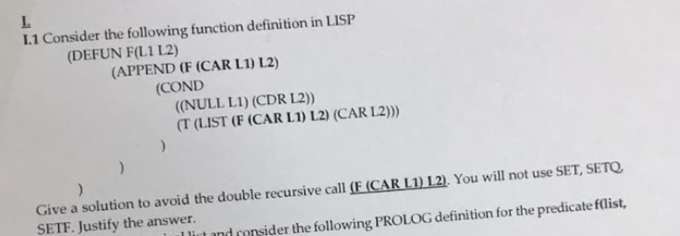
(DEFUN F( l1 l2)
((lambda (v)
(cond
((null l1) (cdr l2))
(t (list v (car l2)))
)) (f (car l1) l2)
)
)
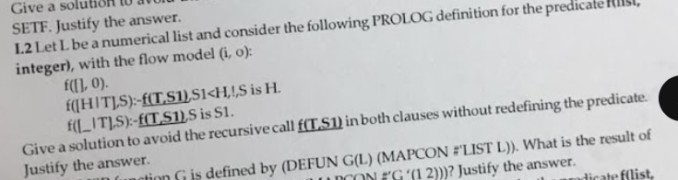
f([H|T],S):-
f(T,S1),
aux(H,S,S1).

aux(H,S,S1):-
S1<H,!,
S is H.
aux(_,S1,S1).

(1 2 2 2)
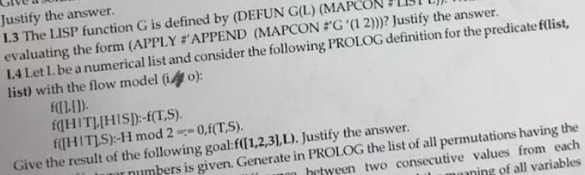
Enter the second clause and keep calling it until f([],[]). We return to the second clause, add H and return => [3] => [2, 3] => [1, 2, 3] . Then we redo f([3]) with the 3rd clause which fails. We redo f([2,3]) => call f([3]) (1st clause) returns [3] => return [3] => f([1,2,3]) returns [1,3]. Call again f([3]) (2nd clause) which fails => false
Final: [1,2,3] [1,3] false
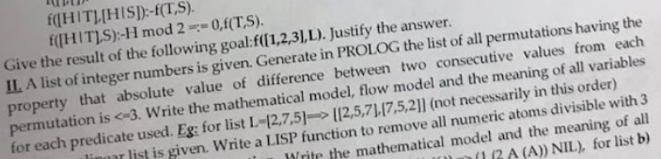
candidate(E,[E|_]).
candidate(E,[_|T]):-
candidate(E,T).

valid(A,B):-
abs(A-B)=<3.

perm(L,Rez):-
candidate(E,L),
perm_aux(L,[E],1,Rez).

perm_aux(L,Col,Lg,Col):-
length(L,Len),
Len =:= Lg.

perm_aux(L,[H|Col],Lg,Rez):-
length(L, Len),
Lg<Len,
candidate(E,L),
\+ member(E, [H|Col]),
valid(E,H),
Lg1 is Lg+1,
perm_aux(L, [E,H|Col], Lg1, Rez).

; V2
eliminate(E,L,[E|L]).
eliminate(E,[A|L],[A|X]):-
eliminate(E,L,X).

perm([],[]).
perm([H|T],P):-
perm(T,L),
eliminate(H,L,P).

valid([H1,H2]):-
abs(H1-H2)=<3.
valid([H1,H2|T]):-
abs(H1-H2)=<3,
valid([H2|T]).

sol(L,P):-
perm(L,P),
valid(P).

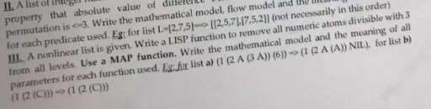
(defun remE(l)
(cond
((null l) nil)
((and (numberp l) (= 0 (mod l 3))) nil)
((atom l) (list l))
(t (list (mapcan #'remE l)))
)
)

(print (remE '(1 (2 a (3 a)) (6)) ))
(print (remE '(1 (2 (c))) ))

Model B1
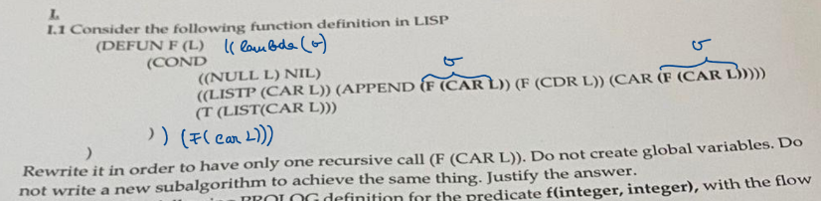
(DEFUN F(L)
((lambda (v)
(cond
((null l) nil)
((listp (car l)) (append v (f (cdr l)) (car v)))
(t (list (car l)))
)
) (f (car l)))
)
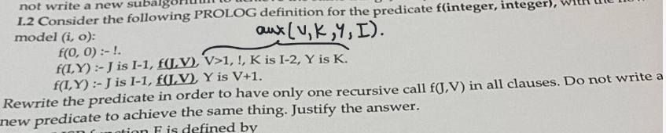
f(0,0):-!.
f(I,Y):-
J is I-1,
f(J,V),
aux(V,K,Y,I).

aux(V,K,Y,I):-
V>1,!,
K is I-2,
Y is K.
aux(V,_,Y,_):-
Y is V+1.

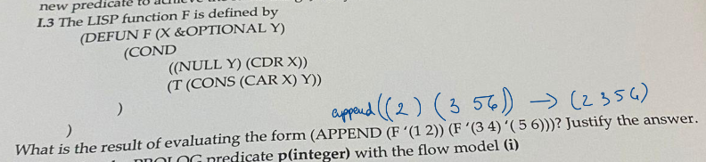
(F ‘(1 2)) -> (2)
(F ‘(3 4) ‘(5 6)) -> (3 5 6)
- (2 3 5 6)
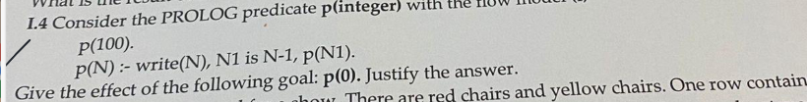
Infinite recursion
Daca aveam N+1, atunci 0…100 true
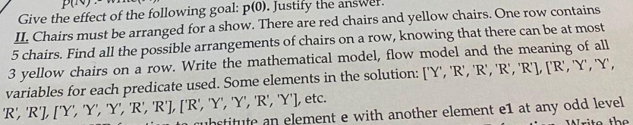
candidate('Y').
candidate('R').

arr(Rez):-
arr_aux([],0,Rez).

arr_aux(Col, 5, Col).
arr_aux(Col, Lg, Rez):-
Lg<5,
candidate(E),
count([E|Col], 'Y', N),
N=<3,
Lg1 is Lg+1,
arr_aux([E|Col],Lg1,Rez).

count([],_,0).
count([H|T],E,Rez):-
count(T,E,R1),
H = E,
Rez is R1+1.
count([H|T],E,Rez):-
H \= E,
count(T,E,Rez).
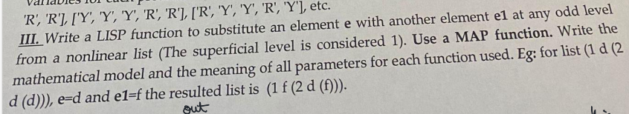
(defun repl(l e e1 lvl)
(cond
((and (atom l) (oddp lvl) (eql e l)) e1)
((atom l) l)
(t (mapcar #'(lambda (x) (repl x e e1 (+ 1 lvl))) l))
)
)

(defun mainRepl(l e e1)
(repl l e e1 0)
)
(print (mainRepl '(1 d (2 d (d))) 'd 'f))

Model B3
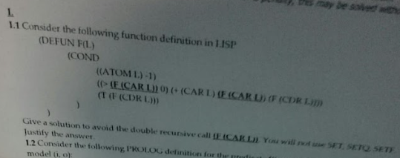
(DEFUN F(L)
((lambda (v)
(cond
((atom l) -1)
((> v 0) (+ (car l) v (f (cdr l))))
(t (f (cdr l)))
)) (f (car l))
)
)
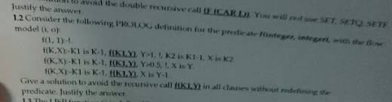
f(1,1):-!.
f(K,X):-
K1 is K-1,
f(K1,Y),
aux(K1,X,Y).
aux(K1,X,Y):-
Y>1,
!,
K2 is K1-1,
X is K2.
aux(_,X,Y):-
Y>0.5,
!,
X is Y.
aux(_,X,Y):-
X is Y-1.
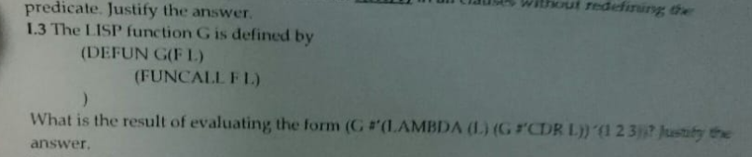
First we call g with the lambda on (1 2 3)
- (lambda(l) (g cdr l) ) (1 2 3) -> cdr (1 2 3) -> (2 3)
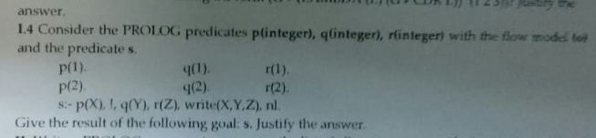
P(x), ! -> we enter the first clause p(1) which outputs 1, move forward and don’t backtrack
->all the combinations with 1 on the first position: 1 1 1 true 1 1 2 true 1 2 1 true 1 2 2 true.
On the first iteration we call p(X), q(Y), r(Z), prints the number and the predicate ends, then backtrack to r and continues the process.
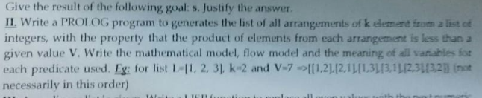
candidate(E,[E|_]).
candidate(E,[_|T]):-
candidate(E,T).

arr(L,V,K,Rez):-
candidate(E,L),
E<V,
arr_aux(L,[E],V,E,K,1,Rez).

arr_aux(_,Rez,V,P,K,K,Rez):-
P<V.
arr_aux(L,[H|Col],V,P,K,Lg,Rez):-
Lg<K,
P<V,
candidate(E,L),
\+ member(E, [H|Col]),
P1 is P*E,
Lg1 is Lg+1,
arr_aux(L,[E,H|Col],V,P1,K,Lg1,Rez).

allArr(L,V,K,Rez):-
findall(R, arr(L,V,K,R), Rez).
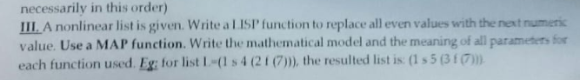
(defun repl (l)
(cond
((null l) nil)
((and (numberp l) (= 0 (mod l 2))) (+ l 1))
((atom l) l)
(t (mapcar #'repl l))
)
)

(print (repl '(1 s 4 (2 f (7)))))

